 SCHOOL *of* BUSINESS AND TECHNOLOGY

Department of Engineering and Aviation Sciences

**Smart Delivery**

**Kevin Harper**

**Eli Nbede**

**Montraz Oliver**

Advisor: Dr. Zhang

May 4, 2020

Design of Autonomous Food Delivery Vehicle

By

Kevin Harper, Eli Nbede, and Montraz Oliver

Submitted to the Department of Engineering and Aviation Sciences in partial fulfillment of the requirements for the degree of Bachelor of Science in Engineering at the UNIVERSITY OF MARYLAND EASTERN SHORE

Date

The author hereby grants the University of Maryland Eastern Shore permission to reproduce and distribute publicly, paper and electronic copies of this document in whole or in parts.

Authors Kevin Harper, Eli Nbede, and Montraz Oliver

Signature

Date

Department of Engineering and Aviation Sciences

Certified by

**LIST OF CONTENTS**

**List of Contents……………………………………………………………………………3**

**List of Figures…………………………………………………………………………………………5**

**List of Tables………………………………………………………………………………….6**

**Abstract…………………………………………………………………………………………………………7**

**1 Introduction………………………………………………………………………………………………8**

**1.1 Background/Motivation………………………………………………………………………………….8**

**1.2 Objective……………………………………………………………………………………………….9**

**1.3 Design Requirements……………………………………………………………………10**

**1.4 Design Constraints…………………………………………………………………………..10**

**2. Project Description……………………………………………………………………..11**

**2.1 System Description………………………………………………………………………...11**

**2.2 System Diagram……………………………………………………………………………...12**

**3. Implementation Plan…………………………………………………………………………….12**

**3.1 Tasks………………………………………………………………………………………………….12-14**

**3.2 Team Organization……………………………………………………………………………….14**

**3.3 Timeline/Milestones/Delivery Plan…………………………………………………..14**

**4. Implementation…………………………………………………………………………………...15**

**4.1 Implementation of Task 1…………………………………………………………………….**

**4.2 Implementation of Task 2……………………………………………………………………..**

**4.3 Implementation of Task 3……………………………………………………………………….**

**4.4 Implementation of Task 4………………………………………………………………………….**

**4.5 Implementation of Task 5………………………………………………………………………...**

**4.6 Implementation of Task 6………………………………………………………………………..**

**4.7 Implementation of Task 7………………………………………………………………………...**

**5. Conclusion**

**LIST OF FIGURES**

Figure 1…………………………………………………………………………………………

Figure 2…………………………………………………………………………………………..

Figure 3…………………………………………………………………………………………………

Figure 4…………………………………………………………………..

Figure 5…………………………………………………………………………………….

Figure 6……………………………………………………………………………………………….

Figure 7…………………………………………………………………………………………………

Figure 8…………………………………………………………………………………………………

Figure 9……………………………………………………………………………………………

Figure 10……………………………………………………………………………………………

**LIST OF TABLES**

Table 1. PROJECT TIMELINE AND DELIVERY PLAN……………………………………………N/A

**ABSTRACT**

**CHAPTER 1. INTRODUCTION**

Autonomous self-driving vehicles are growing exponentially in popularity within new-age technology. There are only a few level 5 self-driving vehicles that require no human activation to drive. These self-driving cars are being used to transport goods and people around the world. Furthermore, the electric car is preferred more often because it offers economic, global, and environmental benefits. The car that we plan to design will deliver food to people autonomously.

**Background/Motivation**

On the campus of the University of Maryland Eastern Shore, there are many students that worry about their next meal and how they are going to get hold of it in a timely fashion. A college student has numerous responsibilities on their table, which limits their ability to obtain food at an ideal time. Throughout an average college student's day, they might have at least 3 to 6 classes per day, extracurricular activities if they are an athlete or in some type of group, and they have to study to stay on top of their grades. Furthermore, most colleges have freshmen who are not allowed to have cars. And if any student who drives a car must pay a lot of money for parking and fees. This limits the number of college students with cars and increases the number of college students walking around campus. “Among the 214 National Universities that reported these data to U.S. News in an annual survey, the average percentage of students who brought cars to campus in the 2016-2017 academic year was 46.8 percent.”

When college students are in their dorm after a long day of classes and stressful lecturing. They still must do homework and study for their classes. At that point, they are tired of walking and going to get some food that is at least .4 miles away. The combination of the gruesome schedule of college students makes and the tireless walking around campus makes it hard for college students to eat food when it's offered.

What if it was possible to send Campus Universities dining services to students around their dorm room or any location they may possibly be located. This would allow campus living students to have the option to not worry about receiving food without stopping their homework and walking half a mile to their cafeteria or dining services. Autonomous Food Delivery System can be created to deliver food around the campus to any recipient, preferably college students living on campus.

At the University of Maryland Eastern Shore students are offered food at the locations including Students Service Center, Engineering & Aviation Sciences Complex, Hawk’s Nest, Waters Hall. In the Students Service Center, they offer students plateau dining and oasis staff dining. The UMES campus offers food, but they have no form of delivery options for students to receive food on campus. Furthermore, college students often argue and complain about the food they receive from the cafeteria. This leads them to eat the July 2014 food that the university provides or any other dining services other than the cafeteria options. There should also be an option for students to choose the food they want to receive via delivery options. Instead of dreading the taste of the food they hate, they can designate their specified food to come to their location.

The idea of creating an autonomous food delivery car was sparked by the Starship Delivery Robot. As shown in Figure1, The Starship Robot is a six-wheeled ground robot that can navigate streets and sidewalks, where they offer on-demand package delivery for consumers and businesses. The Starship Robot was created and operated by Starship Technologies in July 2014.

`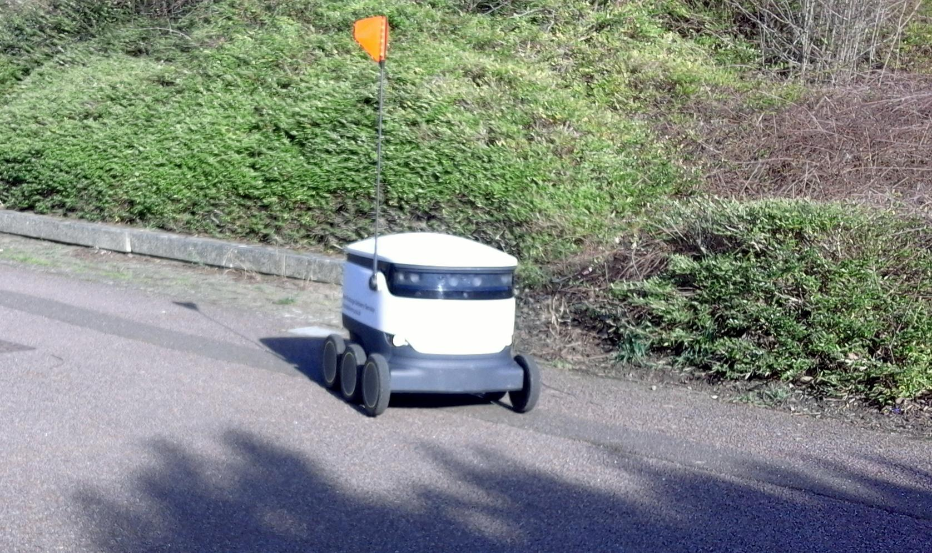

*Figure 1: This figure shows the Starship Delivery Robot founded by Starship Technologies*

**Objective**

Design an autonomous electric car that can deliver dining services around campus universities

**Design Requirements**

1. Carry up to eight pounds of food
2. Can travel up to a 2-mile radius around campus
3. Will deliver one meal at a time
4. Opening and closing of the food compartment
5. Navigates to different locations on campus
6. Speed of 5-10 mph (ca. 16 km/h)
7. Drive on the sidewalk
8. Detects crosswalk
9. Detects Objects
10. Phone Application
    1. Payment System
    2. Ordering System
    3. Food Tracking
    4. SMS
    5. Client App
    6. The client receives information from customer order

**Design Constraints**

1. Tires might not be able to withstand certain road conditions
2. Not recommended driving in the rain, snow, and thunderstorms
3. The system is incapable of going upstairs or ramp
4. The car is incapable of driving on roadways

**Design Method (Approach)**

The first step of designing our vehicle is to build the structure of the car, that includes the frame or chassis, this is where our electrical components, Arduino microcontroller, and Raspberry Pi we are placed at. The next step will be to connect the motor and ESC to the Arduino and our battery. This is how the vehicle will get the power to operate. The next step will be to configure the GPS and compass with our vehicle. After that, we will configure the LIDAR with a Raspberry Pi so that the Raspberry Pi can give the Arduino commands based on the information it receives from the LIDAR i.e. (object avoidance). Once the LIDAR is completed it can be placed in the front of the vehicle. The GPS and compass will both be placed on the outside of the highest part of the vehicle to receive a signal. The next step will be to interface the application “Mission Planner” . This is the application that we will adopt , the waypoints/directions that our vehicle will travel will be placed on here . The use of telemetry will connect the Mission Planner to our vehicle so that they can seamlessly work together. Once the electrical components are all finished , we can close them in under the frame. Next, the food compartment can be set up. a cup will be designed and 3D printed. Also a small frame will also be built to protect the food from rolling around inside the compartment.

**CHAPTER 2. PROJECT DESCRIPTION**

**System Description**

The core system of the electric car is the Raspberry Pi that is interfaced with the camera module, LIDAR sensor, and the Arduino. The driving parameters from the camera and LIDAR such as object detection and lane detection are sent to the Arduino. The Arduino uses the parameters from the Raspberry Pi to control the car. Also, the GPS is interfaced with the Arduino to send and receive location parameters from the website location. The Arduino uses those GPS commands to drive the car to the designated location. Arduino will notify the website when a designated location is achieved through telemetry, so it can then send an SMS to the recipient.

**System Diagram (or Flow Chart)**

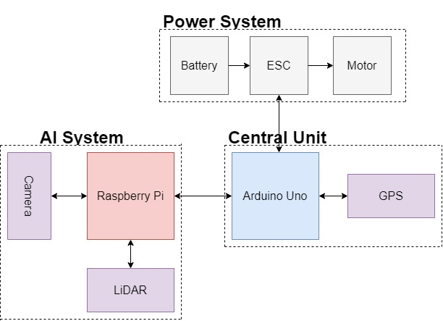

*Figure 2: Electrical System Diagram*

**System Functions**

The Arduino acts as the Central Unit in the system that takes the input and output parameters to control the entire system. The Raspberry Pi is a microcomputer that takes sensor inputs from the Raspberry Pi camera and the LIDAR unit for deep learning functions in the self-driving car. The Arduino uses the commands from the Raspberry Pi, and the GPS to determine navigation parameters to control the motor. The Arduino also gains commands from the App to set designated navigation parameters that leads to the enabling of the power system

**CHAPTER 3. IMPLEMENTATION PLAN**

**Tasks**

Task1: Vehicle Structural Design

Subtask 1.1: CAD of Structure

Subtask 1.2: Implement Structure

Subtask 1.3: Design Lock System

Task 2: Design of Electrical Power System

Subtask 2.1: Identify electrical components

Subtask 2.2: Connect Components

Subtask 2.3: ESC configuration with Arduino

Task 3: APP Design

Subtask 3.1: Create Ordering System

Subtask 3.2: Design Payment System

Subtask 3.3: Design Food Tracking System

Subtask 3.4: Design SMS

Task 4: Design of the Artificial Intelligence System

* Subtask 4.1: Design Semantic Segmentation for System
  + 4.1.1: Gather Dataset
  + 4.1.2: Build Semantic Segmentation Model
  + 4.1.3: Train Model
  + 4.1.4: Test and Evaluate Model
* Subtask 4.2: Detection
  + Deploy Pre-Trained Model to Raspberry Pi
  + Design Motion Control Guidelines
  + Design Serial Communication Protocol

Task 5: Design LIDAR System

Subtask 5.1: Design Program for LIDAR sensor

Subtask 5.2: Design connection for LIDAR sensor

Subtask 5.3: Send control and steering commands

Task 6: Navigation

Subtask 6.1: Extract Geographic Coordinate Units

Subtask 6.2: Configure GPS on Arduino

Subtask 6.3: Configure Compass on Arduino

Task 7: System Testing, evaluation, and enhancement

Subtask 7.1: Test Design Requirements

Subtask 7.2: Evaluate and apply changes if necessary

Subtask 7.3: Repeat process

**Team Organization**

*3.2.1* ***Responsibility of Kevin Harper***

Task 1, Task 2, Task 5, Task 6, Task 7

*3.2.2* ***Responsibility of Montraz Oliver***

Task 1, Task 4, Task 5, Task 6, Task 7

*3.3.3* ***Responsibility of Eli Nbede***

Task 1, Task 3, Task 5, Task 6, Task 7

**Timeline/Milestone/Delivery Plan**

**TABLE 1. PROJECT TIMELINE AND DELIVERY PLAN**

|  |  |  |  |  |
| --- | --- | --- | --- | --- |
| Time | Tasks | | | Comments |
| Montraz Oliver | Eli Nbede | Kevin Harper |
| Week 1-3 | Subtask 1.1 | Subtask 1.1 | Subtask 1.1 |  |
| Week 4 -7 | Subtask 4.1 | Task 3 | Subtask 2.1, 6.1 |  |
| Week 8 - 11 | Subtask 4.1 & 5.1 | Task 3 | subtask 5.1 |  |
| Week 12-13 | Subtask 1.2, Subtask 5.2 | Subtask 1.3, Task 3 | Subtask 1.2, Subtask 2.2 |  |
| week 14-16 | Subtask 4.3-4.4 | Task 3  Subtask 2.3 | subtask 6.2  subtask 2.3 |  |
| week 17-18 | Subtask 4.3-4.4 | Subtask 6.3 | subtask 6.3 |  |
| week 19-22 | Task 7 | Task 7 | Task 7 |  |

**CHAPTER 4. IMPLEMENTATION**

**Implementation of Task 1.**

*4.1.1. Implementation of Subtask 1.1*

*4.1.2. Implementation of Subtask 1.2*

*4.1.3. Implementation of Subtask 1.3*

*……..*

**Implementation of Task 2.**

*4.2.0 Implementation of Subtask 2.0*

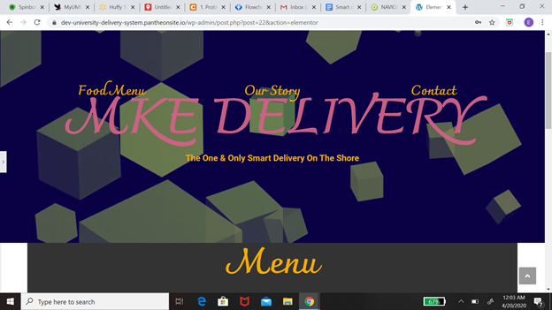

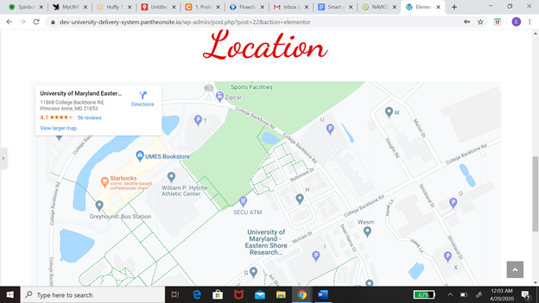

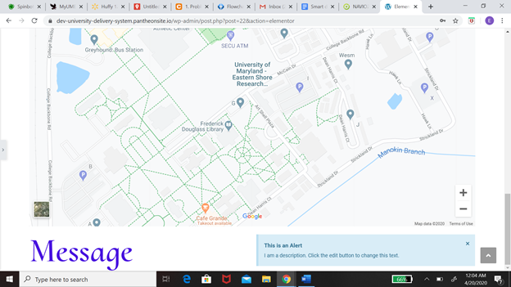

*The task at hand is basically designing a system where customers are able to order from and the employees are able to receive this order. This message from the customer will come with two key information on the location of the customer and another being in the order that the customer please. My first solution with the problem at hand was to create a website using Pantheon. One of the main reasons I chose Pantheon was because it is user-friendly. We should allow* us *to come to the situation with no experience with this application. The approach I took from there was to design the function of the website, which includes the menu, the contact information, location, and basket. The menu was based on the Chick-fil-A menu that is already online so all I needed was a plug-in but one of the problems I ran into while doing that was there was more than one restaurant on campus. So how would I be able to implement multiple menus on this website? After that, I worked on contact information which would include the number. From there I want to create the location and check out basket. I still have some consideration for the program, which includes how to install more than one menu at a time and also have the GPS system* tracks *the food order. I was never able to add the Message system to the website before moving away from this idea.*

[*https://dev-university-delivery-system.pantheonsite.io/wp-admin/post.php?post=22&action=elementor*](https://dev-university-delivery-system.pantheonsite.io/wp-admin/post.php?post=22&action=elementor)

*4.2.1 Implementation of Subtask 2.1*

*The next path after leaving the website was to create a cell phone app. One of the reasons why I decided to work with a cell phone app was that it is way more versatile. When it comes to different applications like the problem I have with the messaging system and including the map on the website. The next step to the solution would be to create an application just for the customer. Features on this application would include placing orders, allowing payment sharing, location, messaging system. I will be going to learn more detail about every single feature on this. At first, I need to explain the steps and procedures the App will take to solve these problems. Now I'm going to explain my flow chart, which basically shows my thinking process for creating the application. When you first open it's going to take you to the welcome page and on that page, it's going to include sign-in or sign-up. If you already have an account with us you will be able to sign in to the app. If not, you will have the option to sign up. After you successfully sign in to the app it will take you to the homepage. The information that will be included on the homepage would be a restaurant, shopping cart and you will be able to search the app from the homepage. Each option will take you to a different page. If you decide to click the restaurant page you would be able to select the restaurant you want to order from and once you do that it would take you to the menu of the restaurant. If you’re not satisfied there will be an if statement that will give you the option to take you back to the main restaurant page that has all the different choices. The next part of this app would be the payment, which would include information like credit or debit card information and the name of the person who is buying the food. If you have a promo you can also include that into payment. From there it’s going to take you to a map of the campus and you will pick your location on the map. This would all be included in your messaging system and your receipt and all that information will be sent to the business you order from and you will receive a text saying the order is complete.*

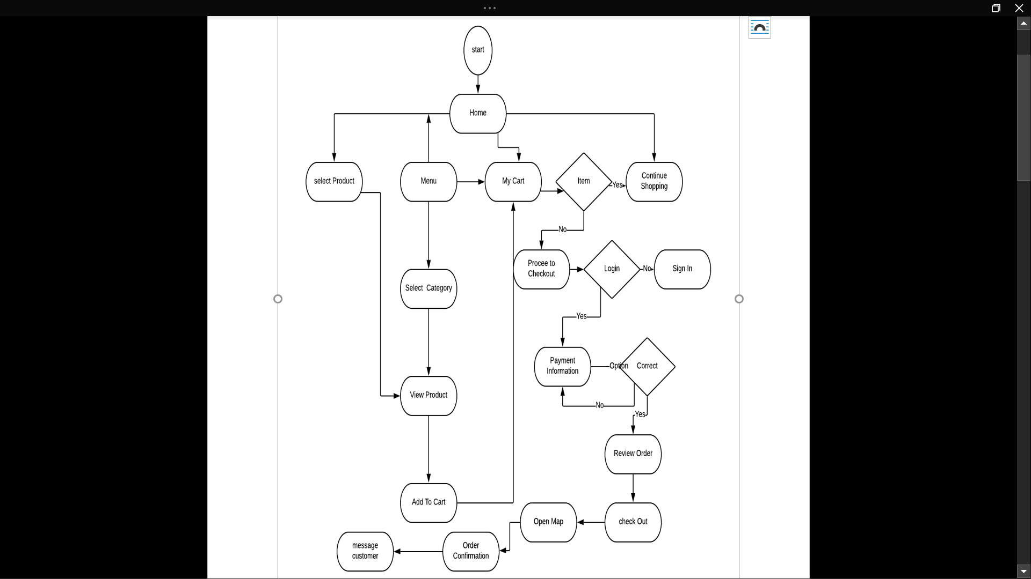

*As we dive into more details about this app. The next stage will be discussing how the sign-up page works and going into the whole structure and mostly explaining figure 2 and that* *should be the flowchart. The first aspect of the sign-up page will also be the most important from the information that will carefully be distributed back-and-forth from the storage to the page itself. The function that is being spoken upon will be the database. The reason why the database was created first was the main way of communication. The decision to use Firebase was a very easy one because Firebase was working very well with the Android studio. To get the Android studio to work with this database all you need to do is connect the IP address and then the plug-in will be able to function well on your Android studio. The next step will be creating the interface which will display multiple different options including boxes and buttons. When you log in to the app The first thing you're coming to counter with would be the sign in page and write below that will be the sign-up page. The way to sign in and sign up will basically be a check system. The way the system works is if you are already a pre-existing customer or app owner. Your information will already be stored in the database so when you put it in your password and your user name and the system will compare the information you put into the information that is stored in a database and check to see if they are the same thing so it would take you to the homepage of the application if not it will return a message saying wrong information. Also have to include people who don’t have an account. In the log game, there will be a sign-up button which would take you to the next page and on them that would include your information like name, address, phone, email, and your password. After all this information is put into the database it will take you back to the login page so you can apply this information and see if everything works - it’s successful. It would take* *to the homepage and that will lead to the next journey of the application.*

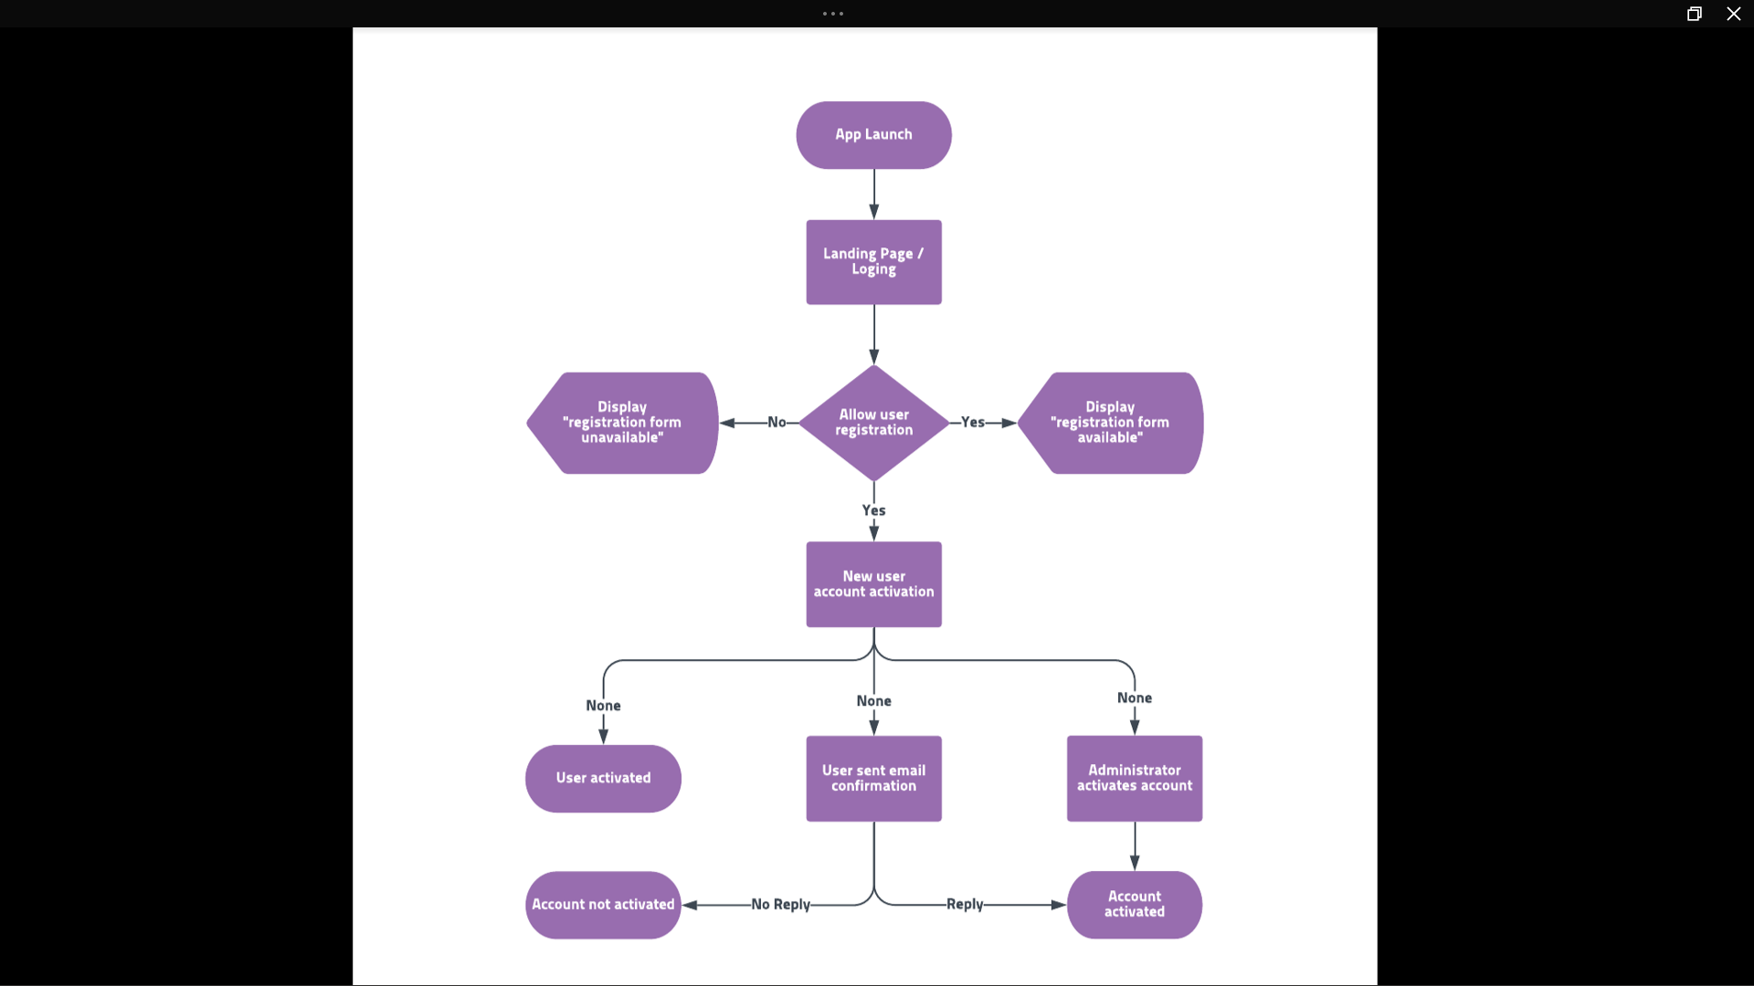

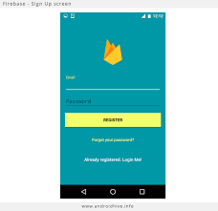

*4.2.2 Implementation of Subtask 2.2*

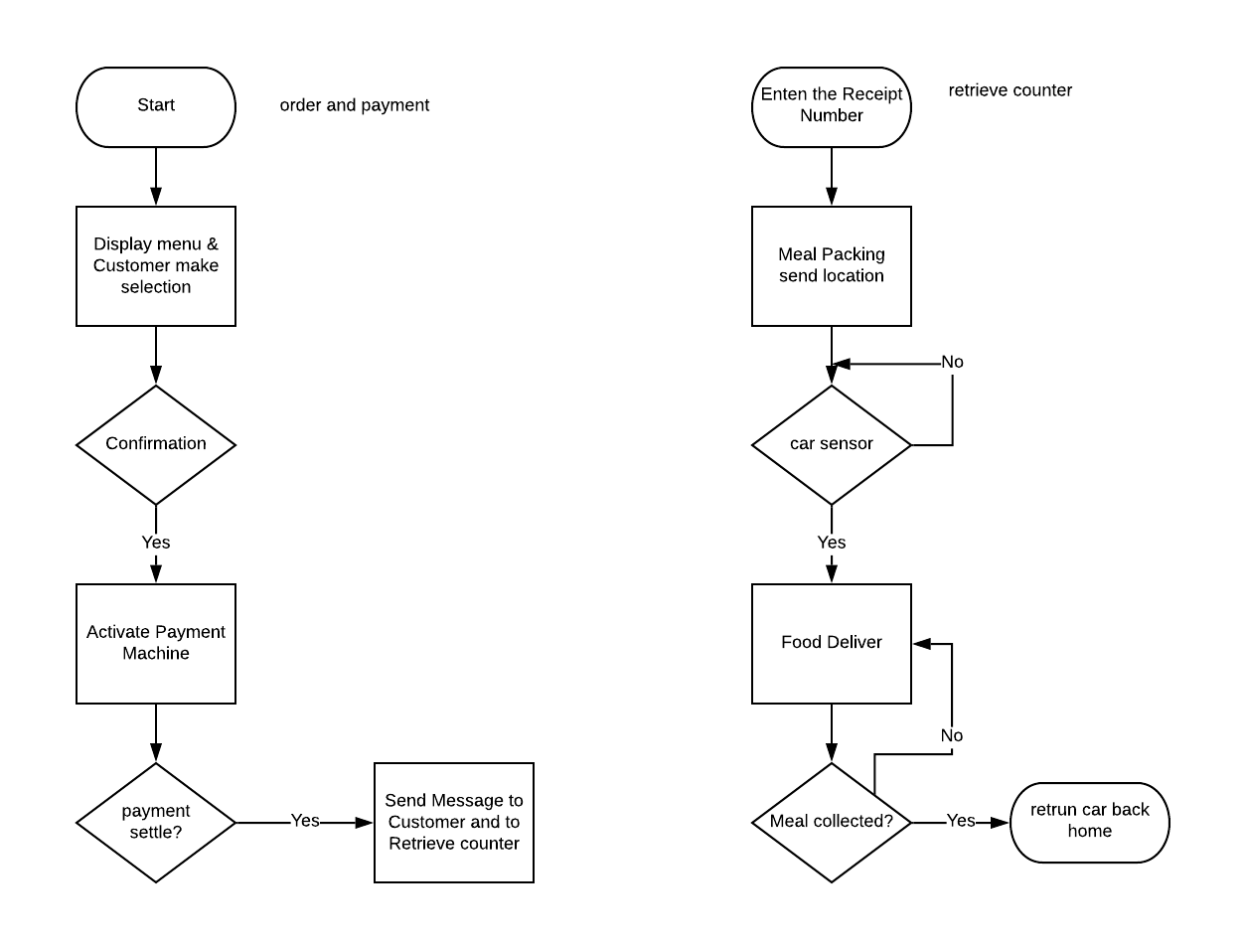

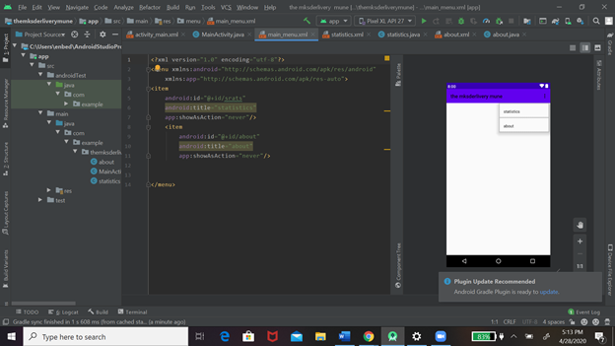

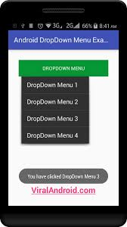

*4.2.3 Implementation of Subtask 2.3*

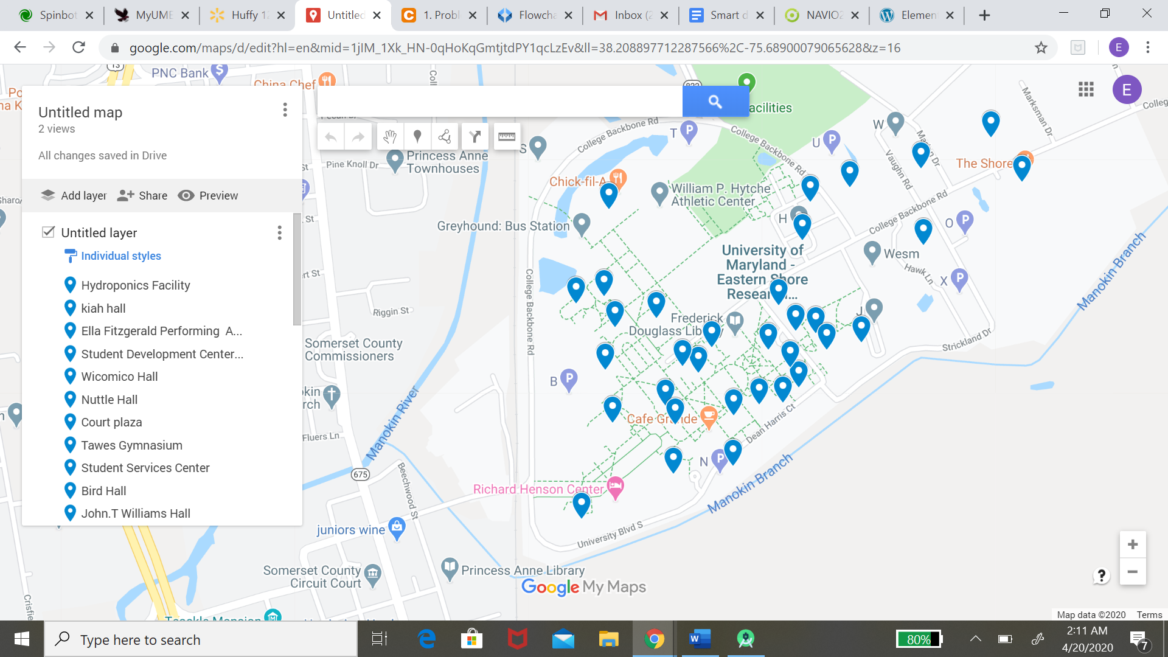

*4.2.4 Implementation of Subtask 2.4*

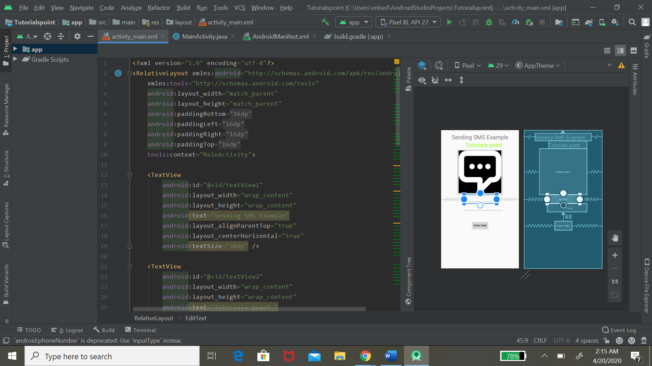

**Implementation of Task 3.**

*4.3.1 Implementation of Subtask 3.1*

*4.3.2 Implementation of Subtask 3.2*

*4.3.3 Implementation of Subtask 3.3*

**Task 4: Design of an AI System**

***4.4.1 Implementation of Subtask 4.1.1 -Gather Training Data***

**Detected edges on the sidewalk via OpenCV:** The initial approach was to detect the sidewalk edges in multiple frames with computer vision tactics. Figure # shows the implementation of learning how to read and write files using OpenCV in Python. The work of canny edge detection was used to detect the edges on the sidewalk shown in figure #. Furthermore, the implementation of the edge detection source code and the resulting image is shown in figure # and figure # respectively. For some time I switched my focus to deep learning and building a neural network to detect the sidewalk.

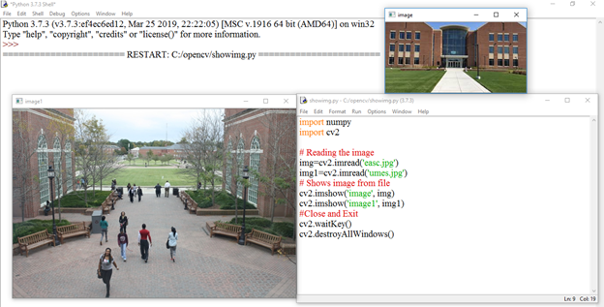

*Figure #: Source code of reading and showing images in OpenCV*

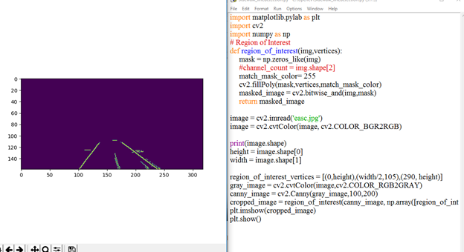

*Figure#: Source code and resulting image of canny edge detection using Python OpenCV library*

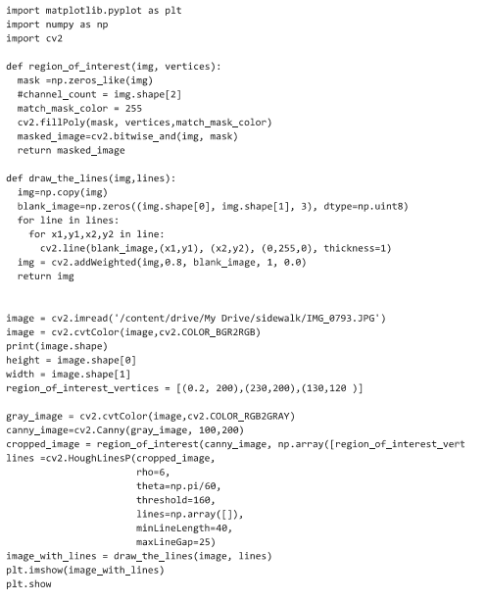

Figure #: Source code for the sidewalk edge detection shown in figure #

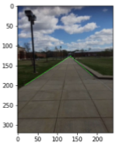

*Figure #: Showing sidewalk edge detection on an UMES Campus sidewalk*

**Implementation of Subtask 4.1 - Gathering Data:** My first subtask in the object detection deep learning process is to gain a lot of data to be able to train my neural network. Data includes at least 100-1000 images depending on the detection. The first task of gathering data is capturing images. Figure # shows the action of capturing images and importing the files on the PC. Gathering data for object detection also includes annotating objects in an image. The Annotation tools that were approached were labeled, that is shown in figure #. Also, labeling was an initial tool for annotating boxes for object detection, as shown in figures # and #. Figures # and # show the images in horizontal format, which is not reliable data to annotate. Not only gathering sidewalks for detection, but also gathering data for crosswalks was a task for the artificial intelligence system. Figures # and # show the annotations and data gathering crosswalks from pictures captured on UMES campus and google images. After annotating images in labeling, the new file generated is an XML file which is shown in figure #. Decision was made to focus on the annotation tool using label me. Label I is an annotation tool best used for polygon annotation and semantic segmentation of objects rather than using a b-box detection method.

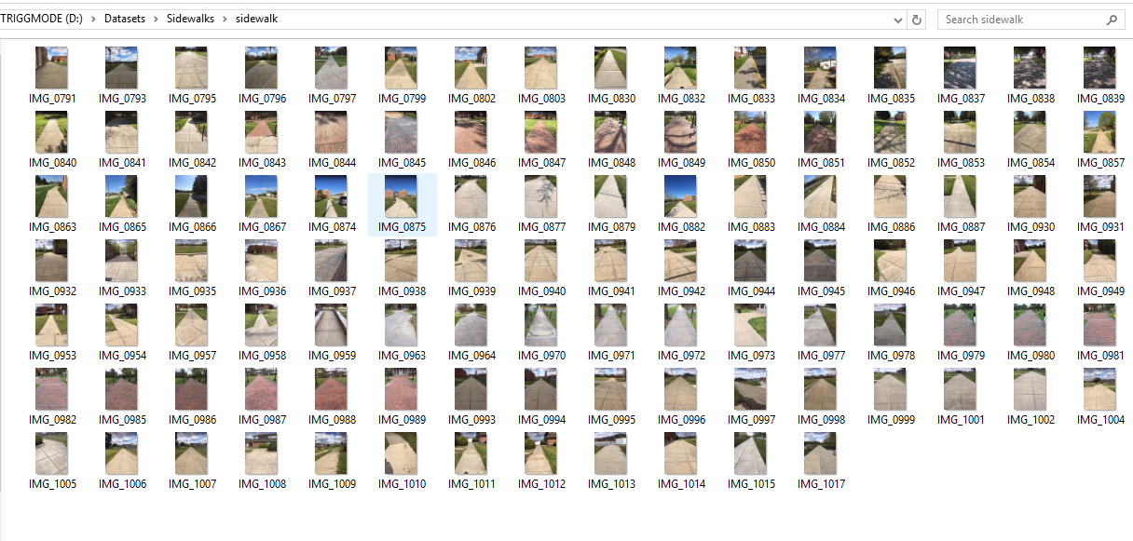

Figure #: Files of images captured from iPhone camera

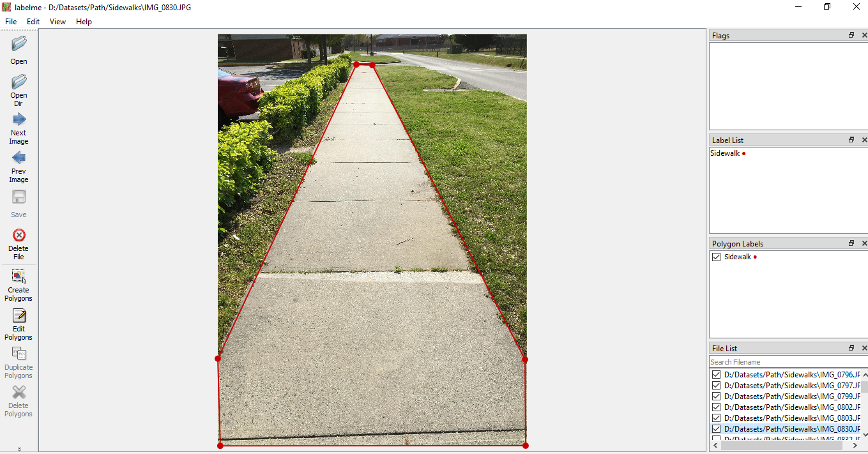

Figure #: Annotating Sidewalk using labels

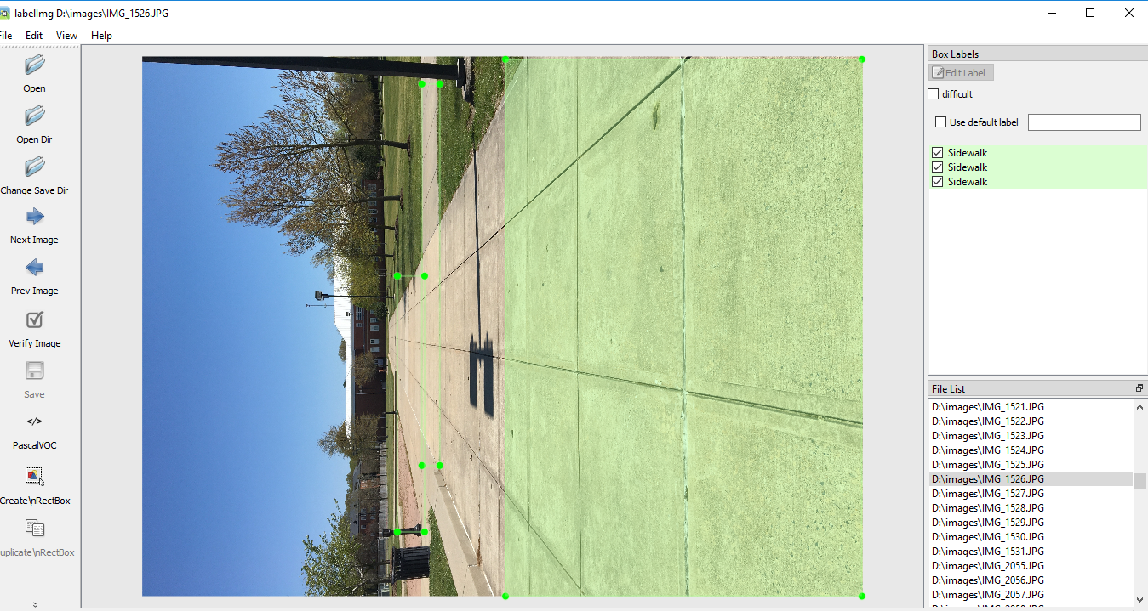

*Figure #: Annotating Sidewalk using labeling.*

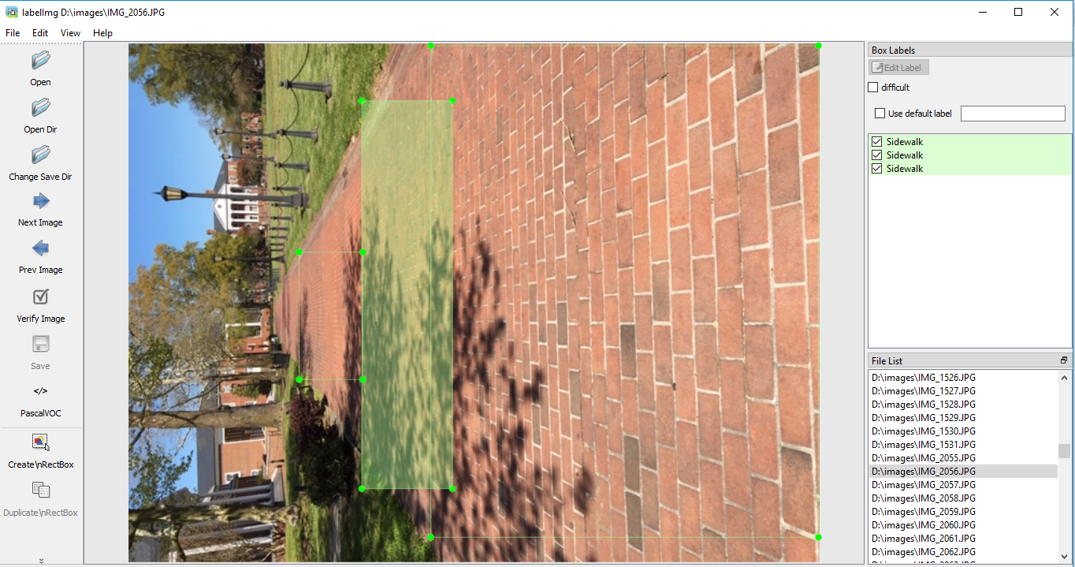

*Figure #: Annotating Sidewalks using labeling.*

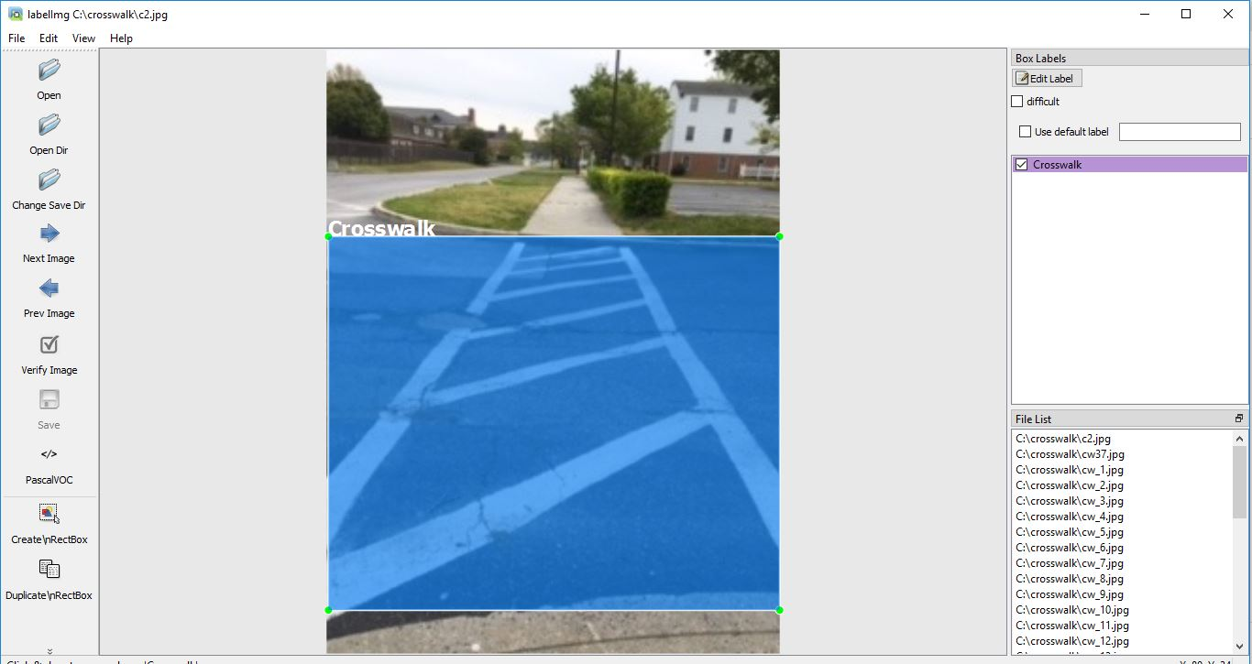

*Figure #: Annotating crosswalks on the UMES Campus.*

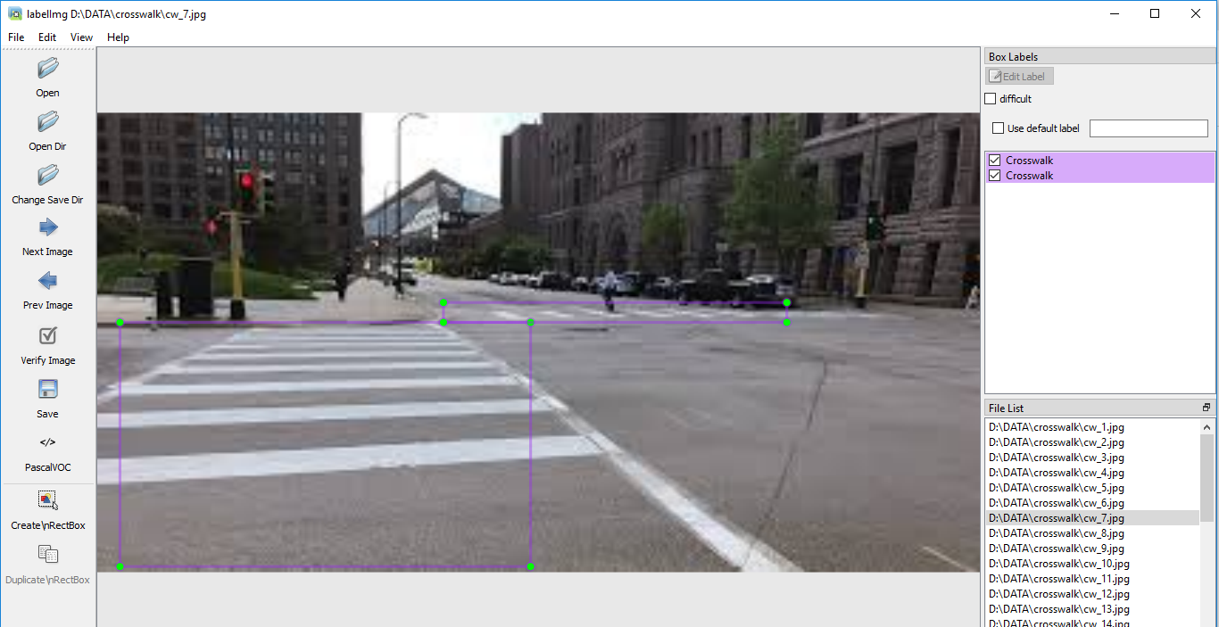

*Figure #: Annotating Crosswalks (Picture from Google Maps)*

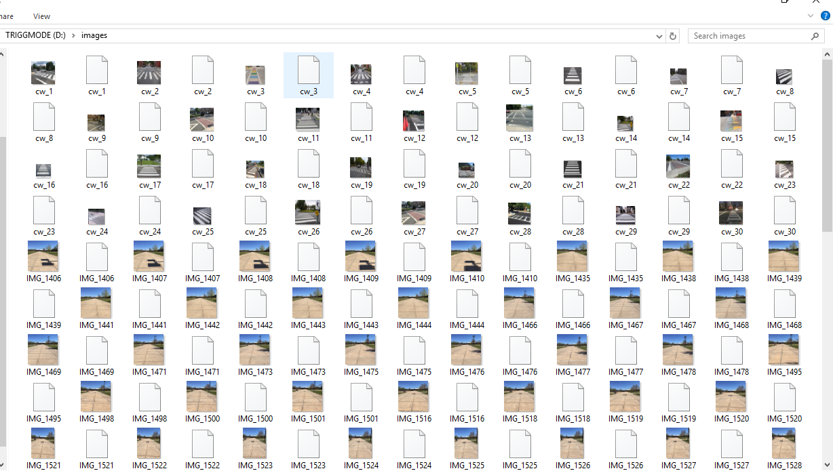

*Figure #: Files including XML files of corresponding JPEG images*

**Subtask 4.1.1 - Gather Data:**

Figure # shows 200 images captured via iPhone, while each image has a size of 320 x 240. Each image is manually annotated using Labelme as shown in figure # which is an image annotator platform used to build databases for computer vision tasks. Labelme provides a source code to convert the JSON files to Pascal VOC dataset formats, as figure # shows. Pascal VOC format is an object detection format that has two directories that includes the JPEG Images and the Annotations. Figure # shows the setting of commands on the command prompt generating the VOC dataset as shown in figures # and #.

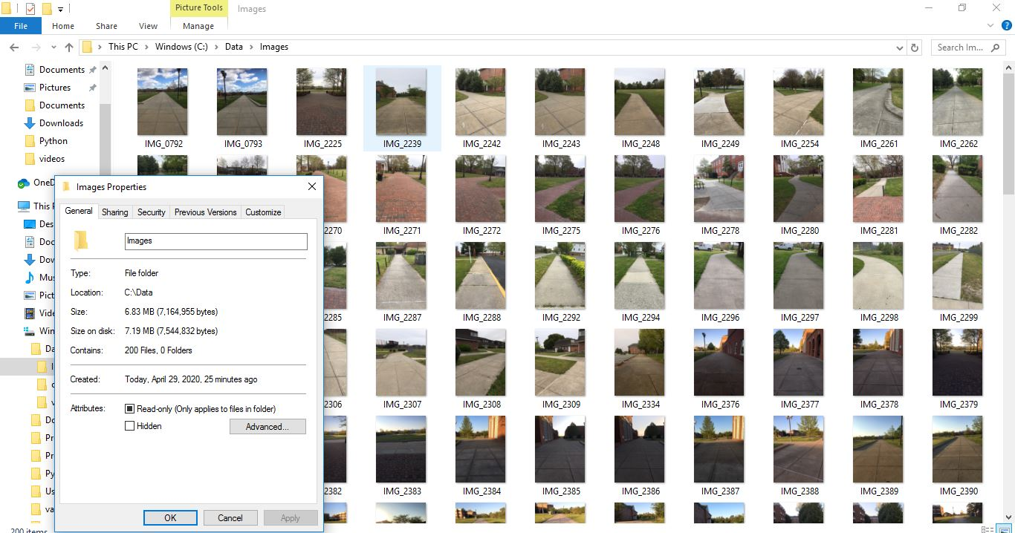

*Figure #: 200 image files*

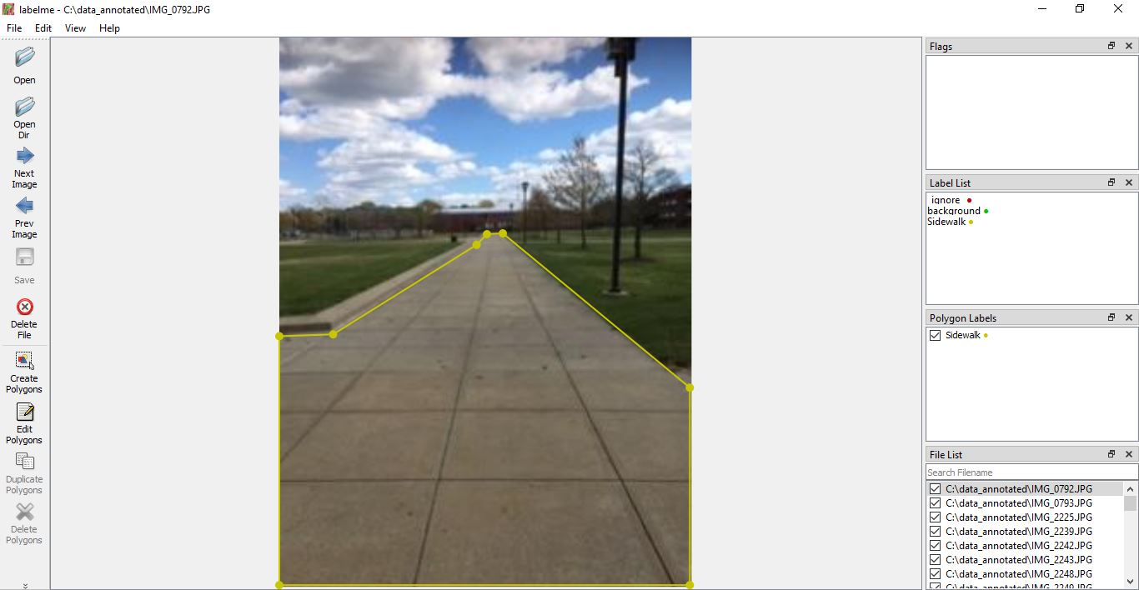

*Figure #: Annotating sidewalk using labelme annotation tool*

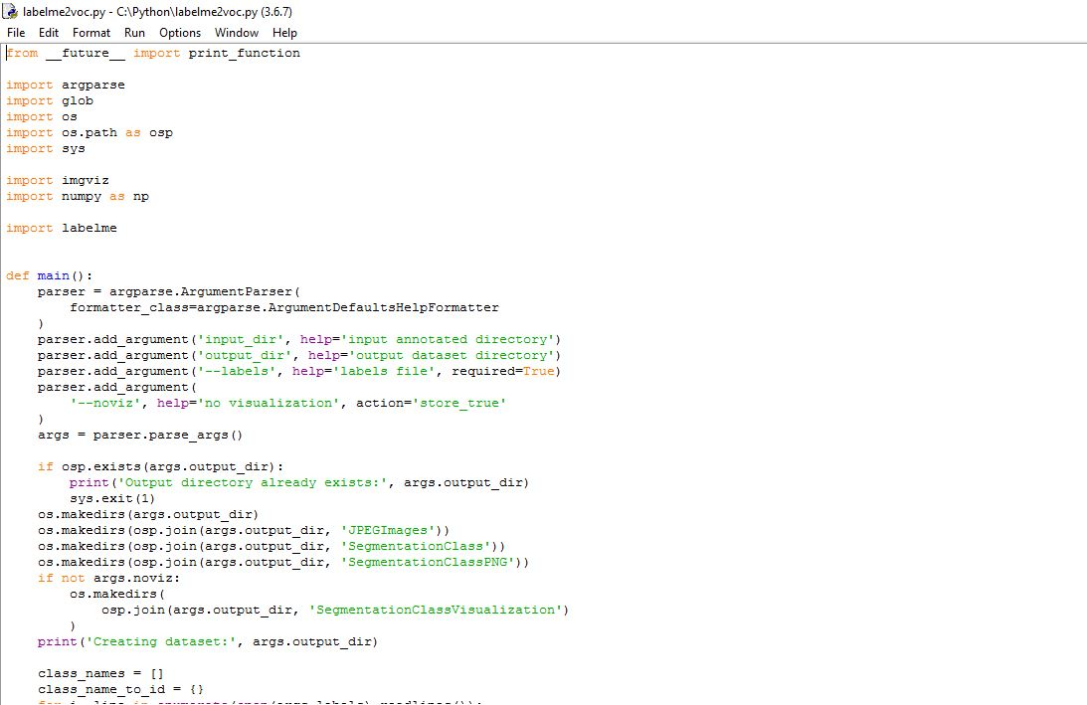

*Figure #: Source code for JSON files on Pascal VOC format dataset*

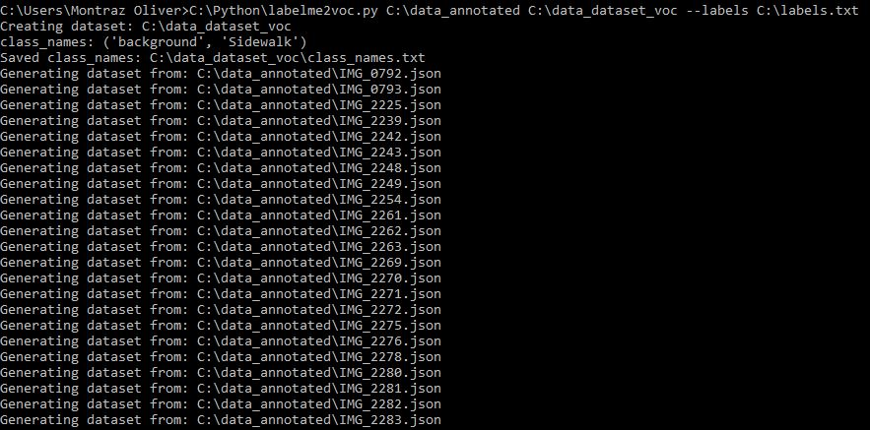

*Figure #: Command prompt to generate the VOC dataset*

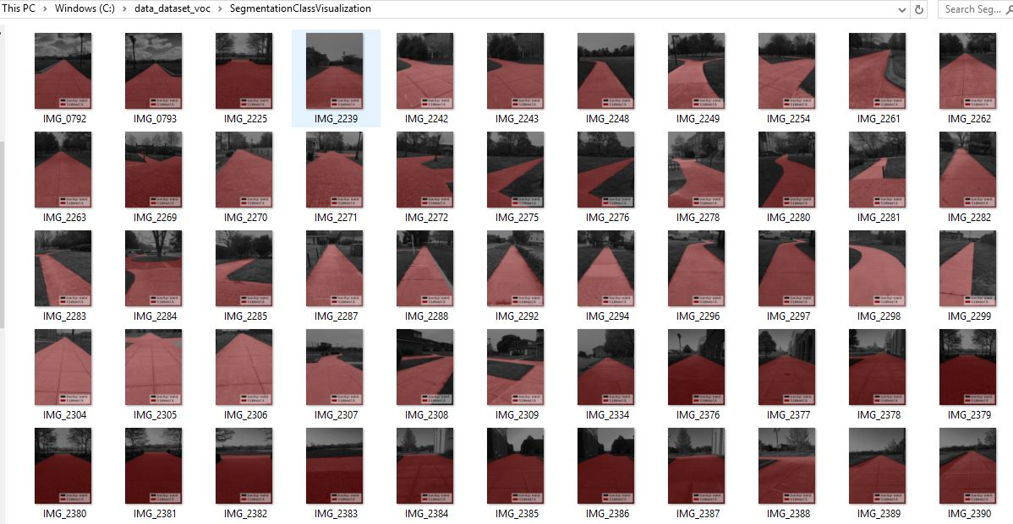

*Figure #: Files including class segmentation visualization from voc dataset format*

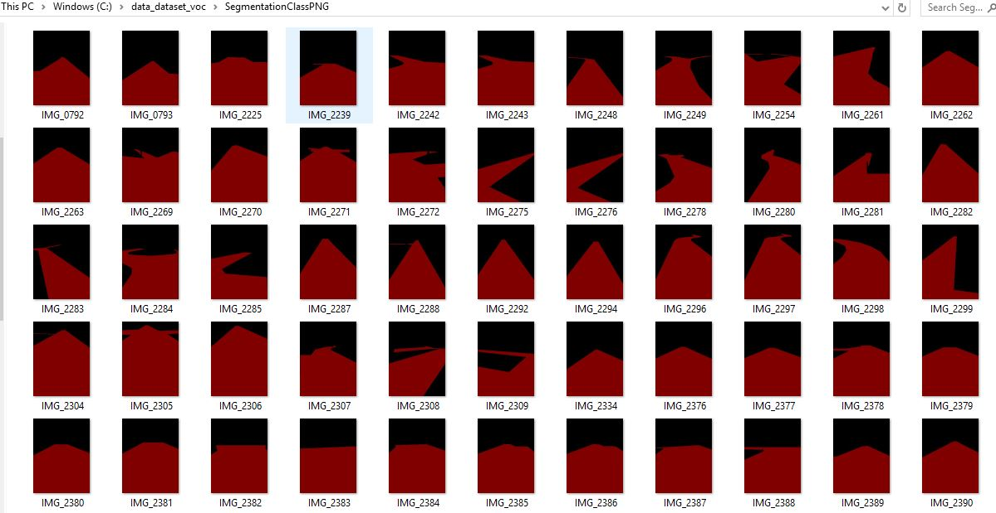

*Figure #: Pixel-wise label masks of sidewalk and background*

**4.1.2 Implementation of Build Semantic Segmentation Model:**

Preparing data to feed the Fully Convolutional network or Simple Semantic Segmentation Network is the first task in building a model in training. As shown in figure #, the dataset must include the input images and its corresponding labels for the train directory, the validation directory, and the test directory. The data was to be splitted as 64 % for training, 16 % for testing, and 20 % for validation. The data is loaded to build a network as shown in Figure # which shows the architecture of a Fully Convolutional Network that is great for Semantic Segmentation. Building a model includes creating convolutional and pooling layers to extract features from the input image. Figure # demonstrates the source code to create a series of convolutions followed by max pooling layers

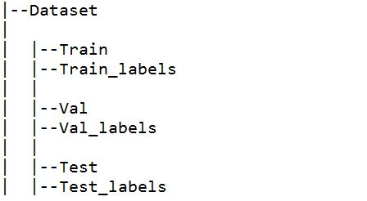

*Figure #: Dataset structure*

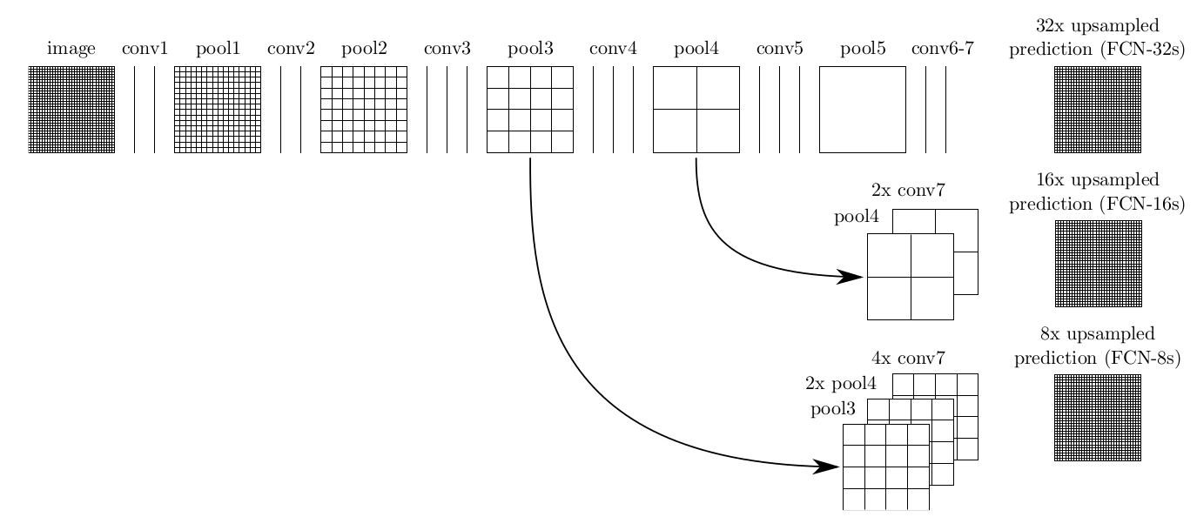

*Figure #: Fully Convolutional Network Architecture*

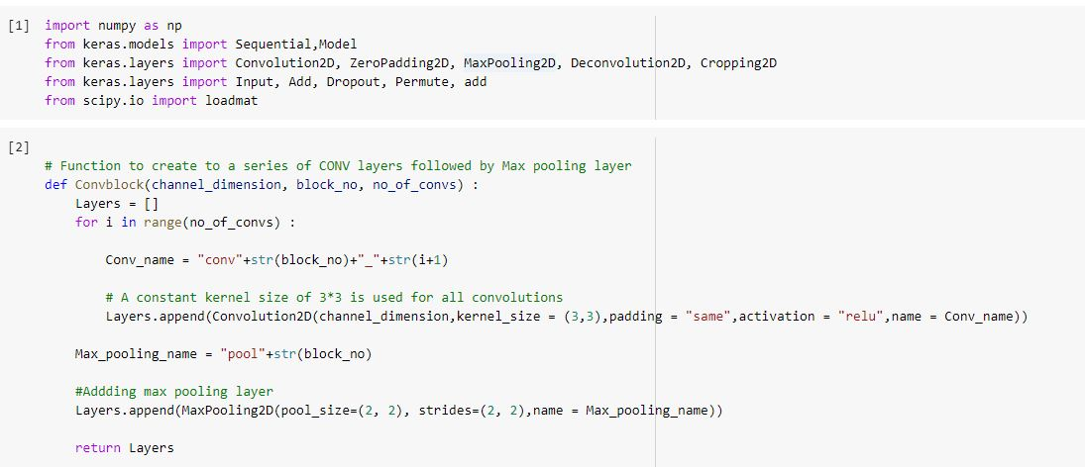

*Figure #: Source code for defining libraries and creating convolutional layers followed by max pooling layers*

4.4.1: Gather Dataset

After trying to create a dataset from scratch with more than 200 images captured and annotated, the decision to adapt a living semantic segmentation database came to fruition. The data is the most important aspect of training a neural network. The goal of the artificial intelligence system is to detect the sidewalk as well as its surroundings. The dataset that needs to be created is for semantic segmentation networks. Semantic Segmentation is a fast growing research field for self driving cars and robots. Semantic Segmentation links each pixel in an image to a label. With semantic segmentation a range of pixels can receive a label as sidewalk, street, car, and etc. This allows the robot platform to detect and extract the usable path from the rest of the scene. In order to achieve this type of goal, there has to be plenty of images to be trained. The dataset being adapted for training is the CamVid Dataset, which is a motion-based segmentation and recognition database. CamVid dataset consists of 701 labeled images: 367 frames for training, 233 frames for testing, and 101 frames for validation, each frame has 360x480. CamVid Dataset offers Ground Truth Labels with 32 semantic classes. Figure # shows an example of Ground Truth Label from the CamVid Dataset. After gathering the correct dataset it is used as an input to feed the neural network model.

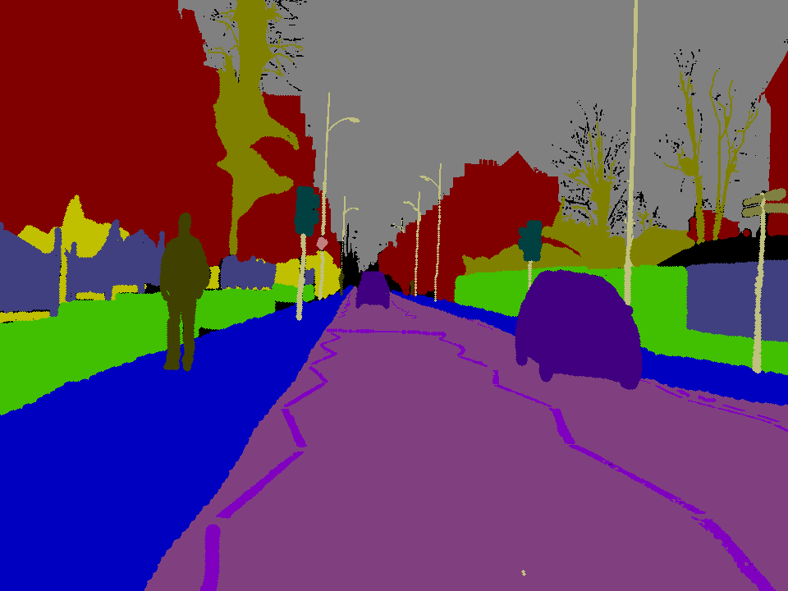

Figure #: Ground Truth Label Image from CamVid Dataset

4.1.2: Build Semantic Segmentation Model

Semantic Segmentation is crucial in self driving vehicles and robotics because it is important for the models to understand the context of the environment they are operating in. Once the dataset is downloaded and converted in a structure that can be used in python. The actions of selecting the type of model comes into the forefront. FC-DenseNet, Semantic Segmentation Model is originally used for image classification and can perform deep supervision tasks. Experiments done on CamVid datasets suggest that FC-DenseNet outperforms SegNet, DeconvNet, FCN, Deeplabv1, and DilatedNet. The architecture of FC-DenseNet Models include one Layer, Transition Down, and Transition Up. The one layer includes a batch normalization, followed by a ReLU, a 3 x 3 convolution, and a dropout with p= 0.2. The transition down is composed of batch normalization, followed by a ReLU, a 1x1 convolution, dropout with p=0.2, and a non-overlapping max pooling of size 2 x 2. Lastly the transition up is composed of a 3 x 3 transposed convolution with stride 2 to compensate for the pooling operation. The model that is being trained on is the FC-DenseNet103, which has 103 layers and a growth rate of 16.

4.1.3: Train Model

Training is the stage of machine learning when the model is gradually optimized and or the model is learning the dataset. The objective is to learn enough about the structure of the training dataset to make predictions about unseen images. In a python program for training there are a number of arguments that have to be processed. Arguments include loading the data, data augmentation, the built model, model loss, number of epochs, batch size, list of classes, front-end, and validation. When evaluating the model, the amount loss occurred in model training has to come into play. As the model's loss measures how off the model predictions are from the labels.

*4.4.4 Implementation of Subtask 4.4*

**Implementation of Task 5.**

*4.5.1 Implementation of Subtask 5.1*

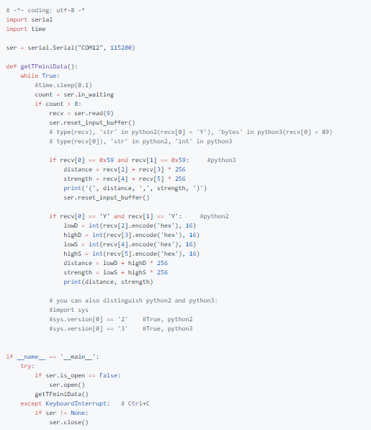 Figure #: This is an adapted code from <https://github.com/TFmini/TFmini-RaspberryPi>. This source code is written in python to program the Tfmini LIDAR

*4.5.2 Implementation of Subtask 5.2*

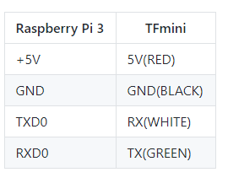

*Table #: TF mini LIDAR* Raspberry Pi 3 configuration

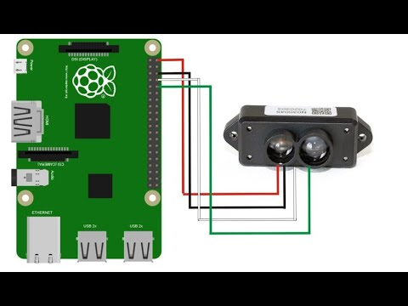

*Figure #: Raspberry Pi 3 and TF mini LIDAR connection*

*4.5.3 Implementation of Subtask 5.3*

**Implementation of Task 6.**

For task 6, the goal was to consider how this car is going to be able to navigate to where it needs to go to be able to make its food deliveries.

The first solution that I have looked into was adopting the autopilot’s solution of the application “Mission Planner”. In mission planning, you have access to satellite maps from Google and Bing and then you can establish waypoints by clicking III on the map, as seen in the picture. I establish 5 waypoints on campus that our delivery vehicle can travel. The issue it comes with is trying to run the simulation to test how the vehicle will travel along the waypoints and then return home

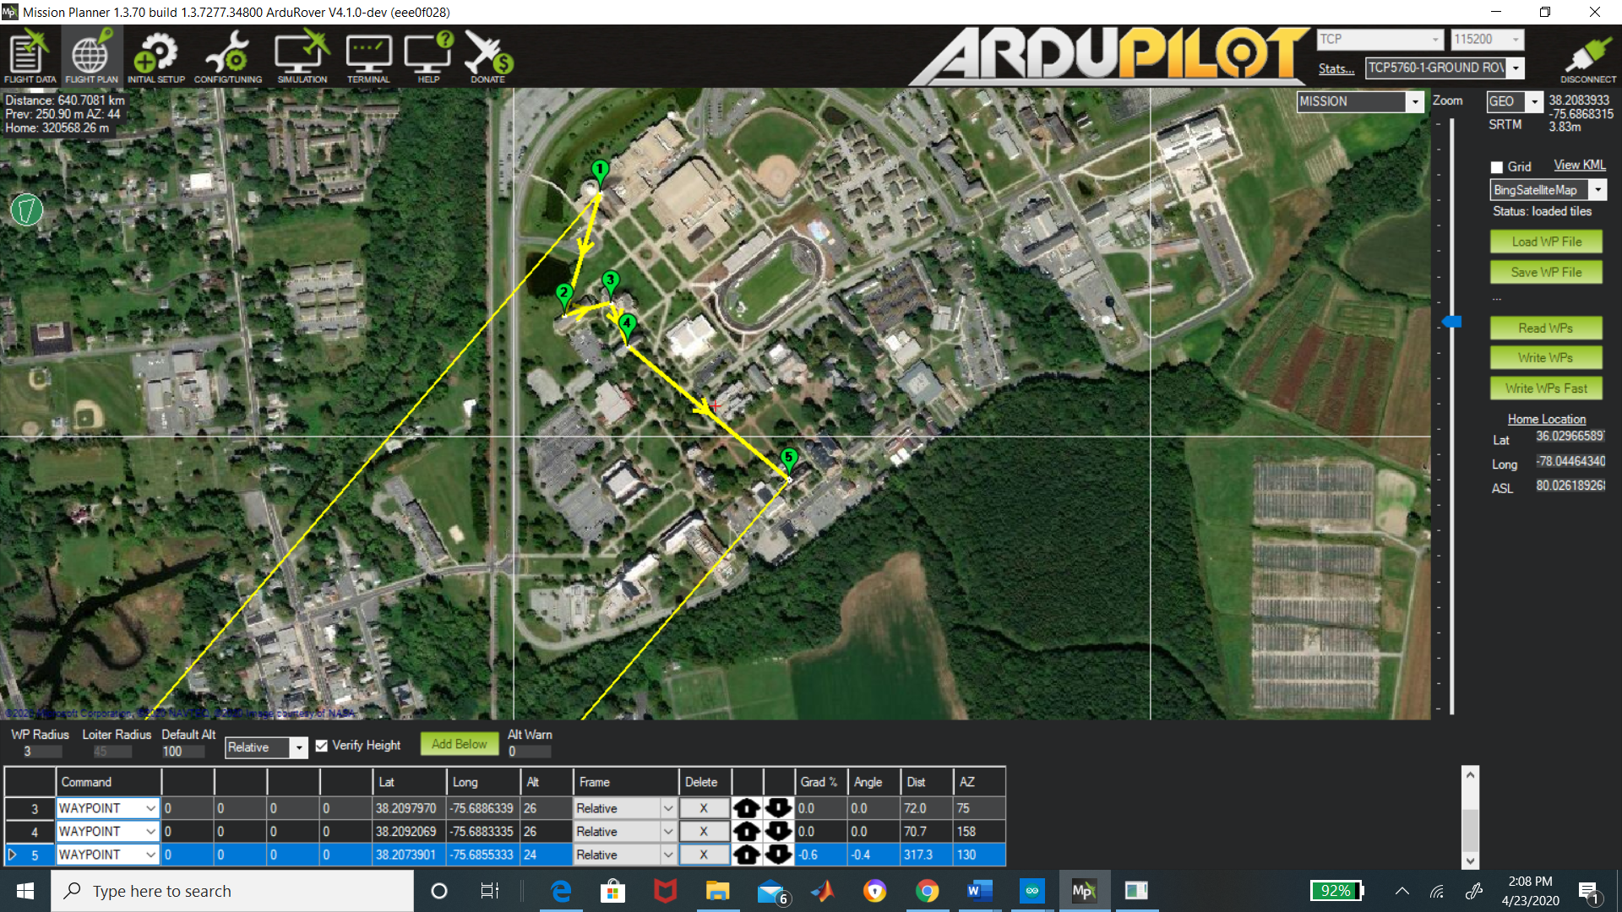

The other solution is accessing using Google Maps platform “Google API”. Google API gives you access to their satellite and the ability to create a set of waypoints/directions. You're allowed up to 25 waypoints for your personal use. In the code below, there is an example you can call upon these directions with your own personal “API” key. When I enter that code below, Google Maps GPS pulls up and then you can set the destination and also places in between that destination. For our vehicle, we want it to travel along the confines of campus, so with google API you can differentiate between if you want a “DRIVING” or “WALKING” route. We will use the walking route because that would avoid the car going on the road.

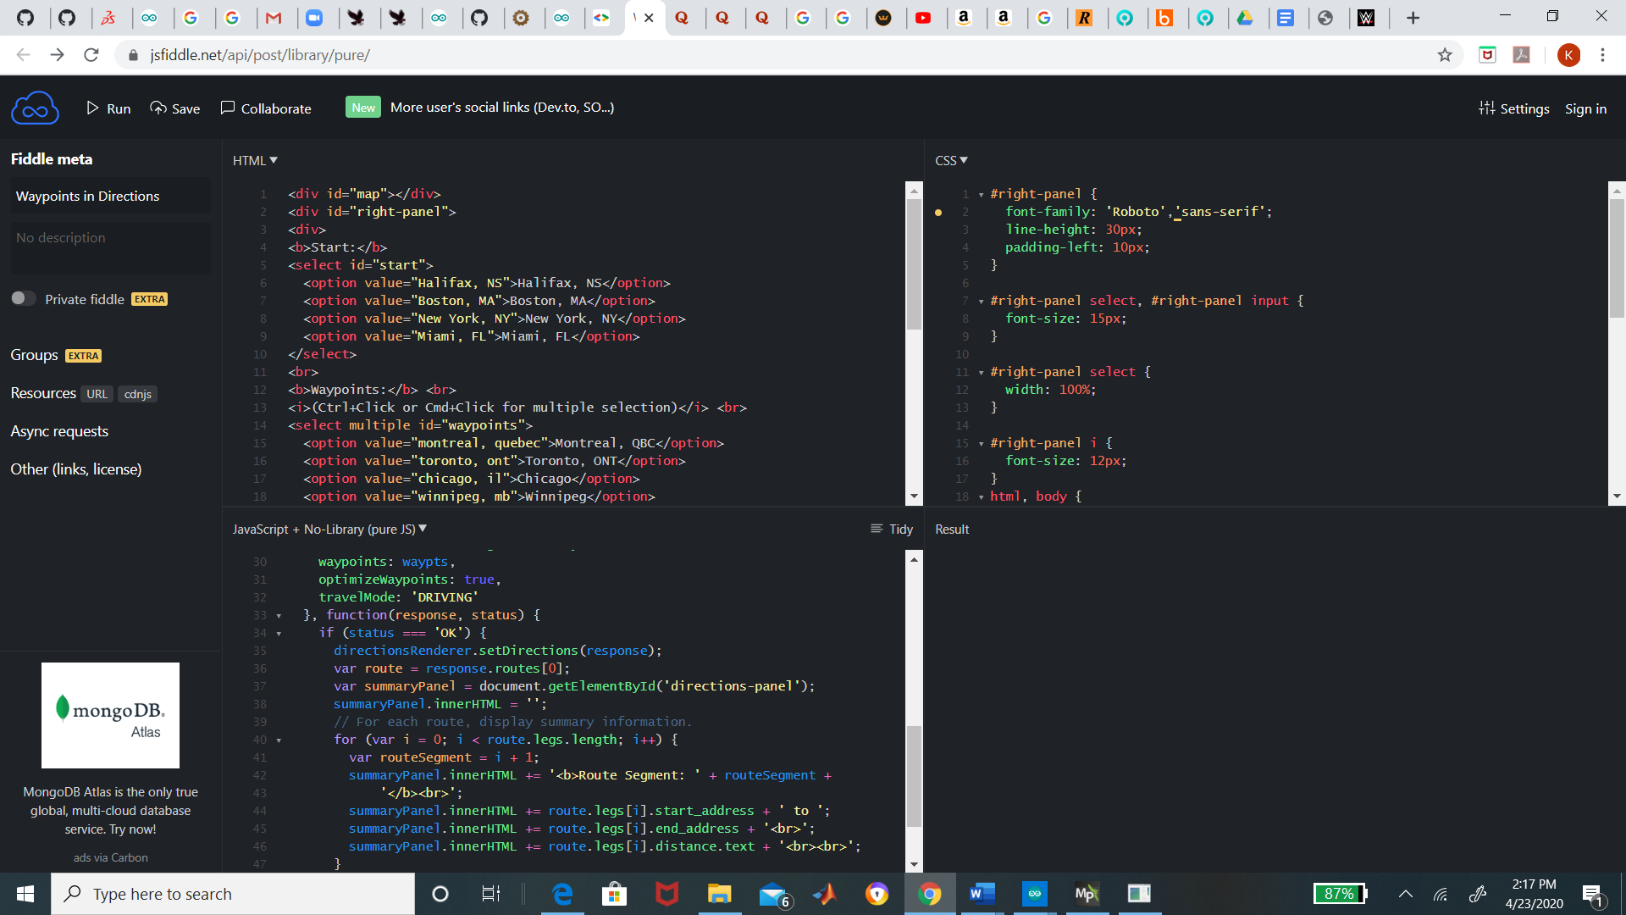

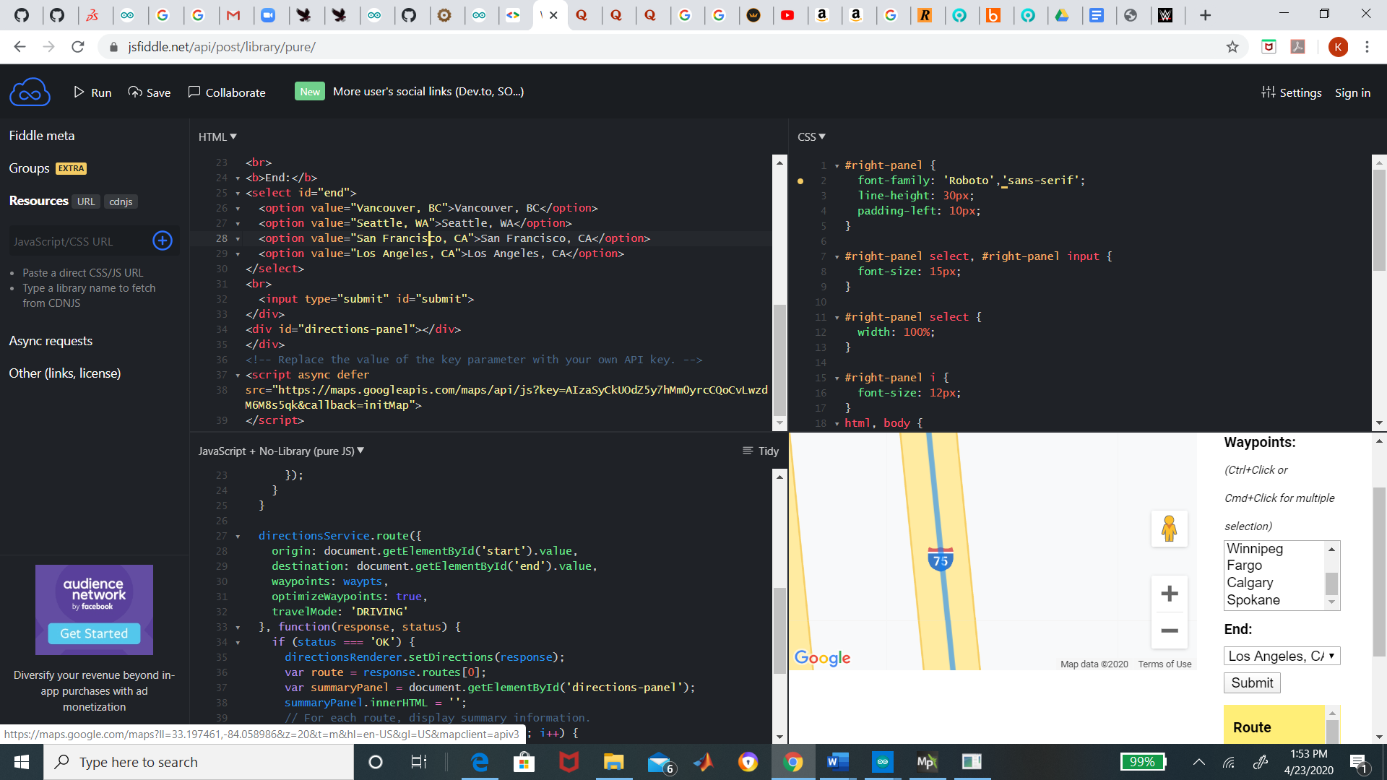

*4.6.1 Implementation of Subtask 6.1*

*4.6.2 Implementation of Subtask 6.2*

*4.6.3 Implementation of Subtask 6.3*

**Implementation of Task 7.**

*4.7.1 Implementation of Subtask 7.1*

*4.7.2 Implementation of Subtask 7.2*

*4.7.3 Implementation of Subtask 7.3*

**CHAPTER 5. PROJECT EVALUATION**

1. Public health
2. Safety
3. Welfare
4. Global Factor
5. Cultural Factor
6. Social Factor
7. Environmental Factor
8. Economic Factor

**CHAPTER 6. CONCLUSION**

**APPENDIX**

**REFERENCES**